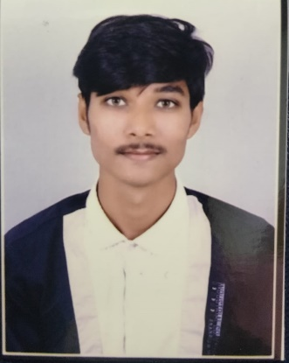

**EDUCATION**

**2017**

**10th**

**2019**

Shree Vivekanand Vinay Mandir Sutrapada

Percentage: 67.14%

**2019-2022**

**Bachelor of Computer Application (BCA)**

Somnath BCA Collage Kodinar

CGPA: 7.94

Parul University Baroda

CGPA: 7.47

**2022-2024**

**CAREER OBJECTIVE**

My career objective is to use my computer application skills to develop innovative software solutions. I want to work in a dynamic environment that encourages learning and growth, contributing to projects that make a positive impact on the IT industry.

digital world.

**Sosa Rahul M**

**Master of Computer Application (MCA)**

**Backend Developer**

**PERSONAL DETAILS**

**Date of Birth:** 14 August 2002

**Marital Status:** Single

**Gender:** Male

**12th Arts**

**CONTACT**

8980848192

Adarsh Nivashi Shala Junagadh

Percentage: 65.66%

sosarahul000@gmail.com

**SKILLS**

* JAVA
* MYSQL
* SERVLET
* SPRING
* C
* C++
* HTML
* CSS
* JAVASCRIPT

Chanakyapuri Society, Raghuvir Nagar, Anandvan Society, New Sama, Vadodara, Gujarat 390002, Vadodara, Gujarat, India – 390002

**LANGUAGES**

* GUJRATI
* HINDI
* ENGLISH

**HOBBIES**

* Travelling
* Cricket

**CRM : Client Relationship Management System**

Company is widely-implemented strategy for managing the company interaction with Customer involving the technologies to organize automat and synchronize business process and activity.

**Java Backend from Tops Technologies**

**(Vadodara)2023-2024**

* Core Java, Advance Java, Spring Framework, Hibernate, JDBC, MYSQL.

**PROJECT**

* Good Learner
* Passionate

**STRENGTH**

* <https://github.com/Rahulsosa0000>
* <https://www.linkedin.com/in/rahul-sosa-194692242>

1946922

**TRAINING**

**WEB LINKS**